

Manhole Cover Status Monitoring Instrument
SJ600-L
Instructions

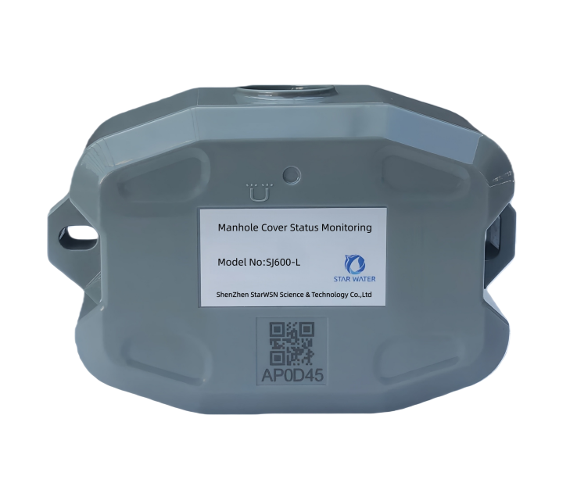
1. Introduction
• The device is designed to monitor manhole cover status and is installed on the underside of the manhole cover. When abnormal movement of the manhole cover meets alarm conditions or liquid overflow occurs, an alarm will be triggered. The device transmits data such as manhole cover status and parameters to the monitoring center via wireless communication. The monitoring center will analyze the data and maintain it as necessary.
• Utilizing LoRaWAN,NB-IoT or 4G wireless communication technology, the device operates on battery power. It features easy installation, long battery life, high detection accuracy, and stable performance.
- Function
• Real-time Monitoring & Alerts
The device provides real-time response to changes in manhole cover status (e.g., overflow, tilt, opening) and transmits alarm signals. It simultaneously monitors battery voltage and triggers low-voltage alerts.
• Scheduled Status Reporting
The device automatically sends daily status reports (including battery voltage and cover status) to ensure operational visibility even in the absence of alarm events.
• Alarm Event Filtering
Equipped with a multi-level alarm filtering system, the device minimizes false alarms caused by vehicle vibrations or transient movements, effectively reducing energy consumption.
• Remote Parameter Configuration
The manhole cover monitor allows remote parameter adjustments, simplifying operation and maintenance.
- Features
• Supports water immersion alarm;
• Ultra-Low power consumption & extended battery life;
• IP68-rated protection;
• LoRaWAN,NB-IoT or 4G network communication;
• High sensitivity & rapid response to abnormal movements;
• Remote device parameter configuration;
• Monitors abnormal actions;
• Alarm/disarm functionality;
• Manual/automatic zero calibration;
- Installation Instructions
• Determine installation position
Mark the screw hole locations on the manhole cover for securing the manhole cover status monitor.
• Surface preparation
Use a manual grinder to remove rust from the marked area，Smooth the surface with sandpaper to ensure a secure fit between the device and the manhole cover.
• Apply Thread-Locking Adhesive
Spray thread-locking adhesive onto the threads of the screws at the installation points. This prevents loosening caused by prolonged vibration of the manhole cover.

Installation Diagram
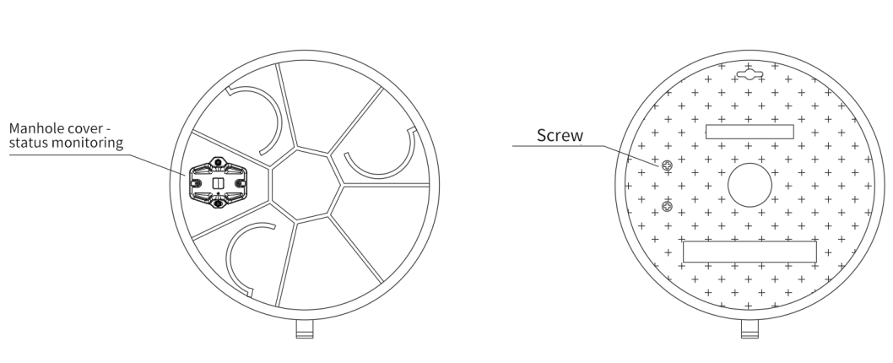
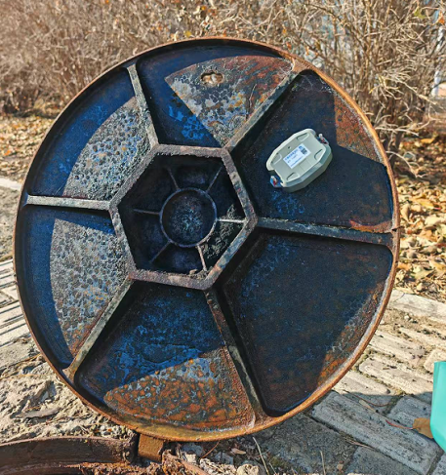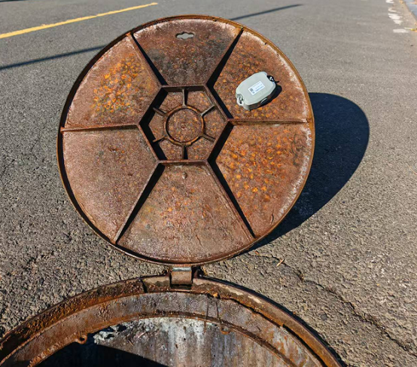

5. Technical Parameter
No. | Item | Parameter
1 | Measurement range | 0°~180°
2 | Measurement accuracy | ±2°
3 | Power | Battery
4 | Battery lifespan | ≥ 3 years
5 | Battery capacity | 19Ah
6 | Communication protocol | MQTT
7 | Communication method | 4G/NB-IOT/LoRaWAN
8 | Data storage | 128Mbit
9 | Protection class | IP68
10 | Transmission interval | 300~65535s
11 | Installation method | Portable
12 | Data docking | SDK data docking
13 | Packaging process | Corrosion-Resistant and waterproof electronic potting process
14 | Explosion-proof grade | Ex ia IIC T3 Ga
15 | Overflow alarm function | Yes
16 | Protective characteristics | Mold-resistant，salt spray-resistant，Prevent high and low temperature
17 | Electromagnetic compatibility | GB/T 17626
18 | Function features | 1.Edge-based early warning: Intelligent data analysis for proactive alerts；  2.Zero Calibration: Supports manual/automatic zero calibration operations；  3. Remote upgrade: FOTA remote updates.；  4.Parameter configuration: Configurable remotely or locally；  5.Adjustable alarm limits with battery life assurance；
19 | Working temperature | -40~85℃
20 | Storage temperature | -20~60℃
6. Dimensions
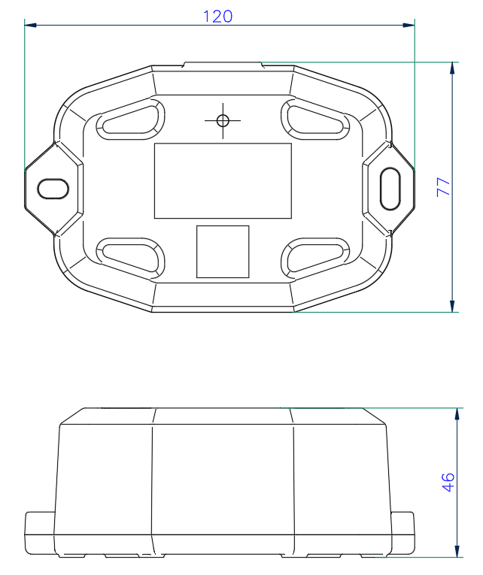
- Packing list:
- SJ600-L *1
- Bracket*1
- User manual*1
- Certificate of conformity*1
- Inspection report*1

CONTACT US
Address: 4th Floor, Building 3, Xifengcheng Industrial Park, Fuyuan 2nd Road,Fuhai Street, Baoan District, Shenzhen, China
www.mercury-iot.com
sales@mercury-iot.com
ShenZhen StarWSN Science & Technology Co.,Ltd

